**ACADEMIC STUDY TRIP:**  ***Wales: Environmental Study of Sustainable Places***

ES 244 (2 credits)  
Prerequisite: ES243 Environmental Study of Sustainable Places (Spring 2023; 2 credits)  
Date: May 18-June 1, 2023 (tentative)

Meet your Trip Leaders:

PROFESSOR JEFFREY AYRES

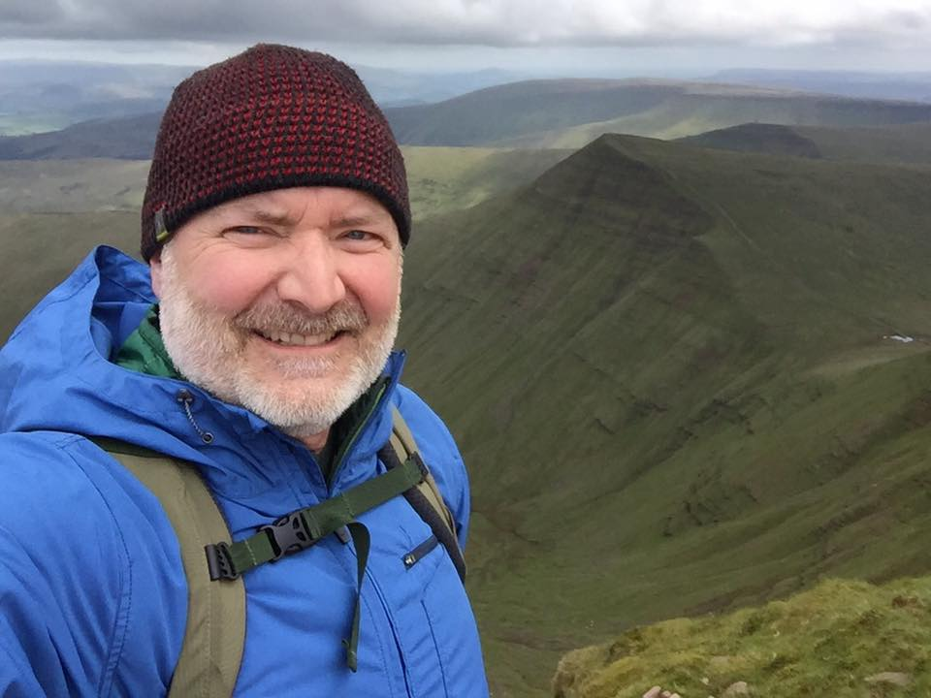

Jeffrey Ayres is a professor and chair of the Political Science and International Relations Department, and director of the Center for Global Engagement at Saint Michael’s College. He is an alum of the U.S. Fulbright Program, and also an adjunct research professor at the Institute of Political Economy, at Carleton University, in Ottawa, Canada. A passionate advocate for campus internationalization, his work-life travels had recently taken him as far as South Korea, China, Japan, Australia, the United Kingdom and Qatar, and as close as Mexico and Canada. Currently, in addition to co-leading the academic study trip to Wales, he leads an annual study trip to Ottawa, Canada, collaborates in the management of the Freeman Foundation-supported International Internship Program in Asia, and serves on the campus Fulbright selection committee and the Peace Corps Prep advisory board.

PROFESSOR LAURA STROUP

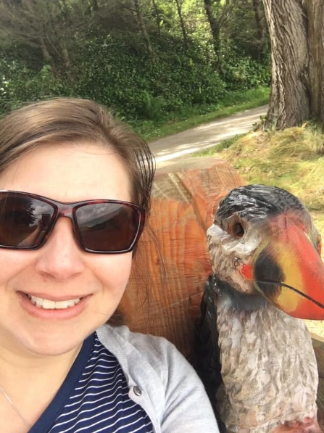

Laura Stroup, Ph.D. is an Associate Prof. of Environmental Studies and Science at Saint Michael’s College. She has been at SMC, and helped to build the Environmental Studies and Science Programs, over the last ten years. Before working at SMC, she was a Water Resources Geographer in a large Geography Department at Texas State University. There, she taught several field programs including one on the U.S. Southwest and another centered on a Devil’s River canoeing trip. Recent research interests concern the water-energy nexus, energy sustainability initiatives on the VT-Canadian Border, as well as environmental restoration projects concerning dam removal and more locally in the College’s Natural Area. In 2019, Prof. Stroup and Prof. Ayres successfully taught, for the first time together, the Environmental Study of Sustainable Places Wales academic study trip course with 15 SMC students. We look forward to another successful Wales course in Summer 2022.